-- Question 1: Find Students Enrolled in More Than One Course.
-- Retrieve the names of students who are currently enrolled in more than one
course along with their enrollment count. Sort the result by enrollment count in descending order.
SELECT s.student_name, count(e.enrollment_id) as enrollment_count FROM
students s JOIN enrollments e
ON s.student_id = e.student_id
group by s.student_id
order by enrollment_count desc;
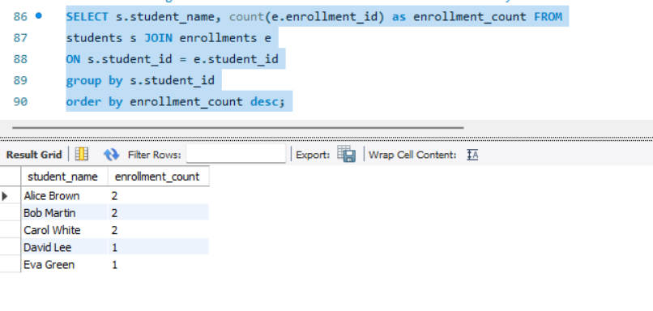
-- Question 2: Identify Instructors Who Are Not Assigned to Any Course.
-- Find the names and departments of instructors who do not teach any course listed in the courses table.
SELECT instructor_name, department from instructors
WHERE instructor_id NOT IN (select instructor_id from courses);
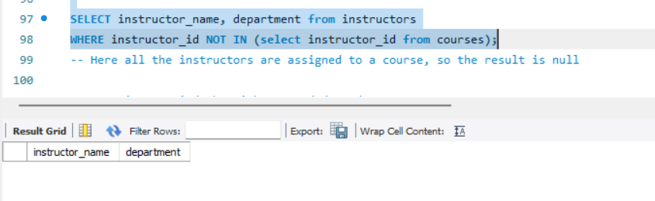
-- Question 3: Find the Highest-Graded Student per Course.
-- For each course, retrieve the course name and the name of the student who achieved the highest grade.
-- If there is a tie, display all tied students.
SELECT c.course_name, s.student_name FROM
courses c JOIN enrollments e
ON c.course_id = e.course_id
JOIN students s
ON e.student_id = s.student_id
where e.grade in (select max(grade) from enrollments group by course_id);
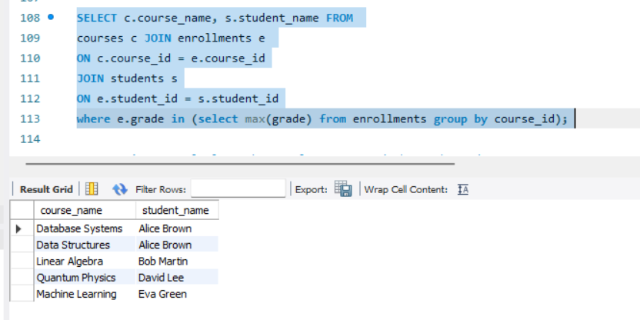

-- Question 4: Calculate the Total Payment Made by Each Student.
-- Display each student's name along with the total amount they have paid.
-- Include students who have made at least one payment. Sort by total amount paid in descending order.
SELECT s.student_name, sum(p.amount) as total_amount FROM
students s JOIN payments p
ON s.student_id = p.student_id
group by p.student_id
order by total_amount desc;
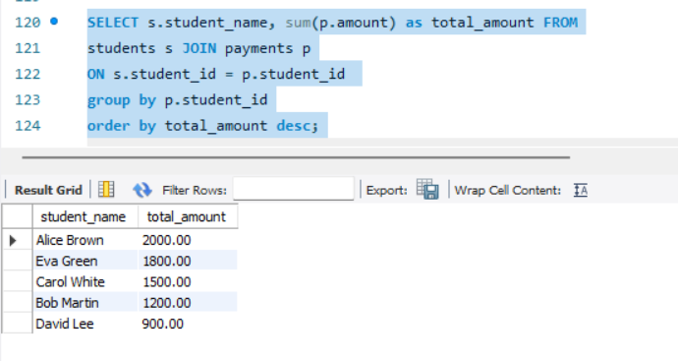
-- Question 5: Find Courses Where the Average Grade Is Below 85.
-- List the course names and their average grades for courses where the class average falls below 85.
-- Round the average grade to two decimal places.
SELECT c.course_name, round(avg(e.grade),2) FROM courses c
JOIN enrollments e ON c.course_id = e.course_id
GROUP BY e.course_id
HAVING avg(e.grade) < 85;
